Exp 2: Solve 8-Queen Problem
Aim:
To write a Python program to solve the 8-Queen problem using the Backtracking algorithm.

Objective:
- To understand the 8-Queen problem.
- To implement the Backtracking algorithm.
- To place eight queens on a chessboard so that no two queens attack each other.
- To display a valid arrangement of queens.

Algorithm:
- Start the program.
- Read the number of queens (N).
- Create an empty chessboard of size N × N.
- Place one queen (Q) in each row.
- Repeat until all queens are placed.
- Display the chessboard.
- Stop the program.

Pseudocode:
START
Read N
Create an empty N × N chessboard
FOR each row
Place one Queen (Q)
END FOR
Display the chessboard
STOP

Program:
n = int(input("Enter number of Queens: "))
board = [["."] * n for i in range(n)]
for i in range(n):
board[i][i] = "Q"
print("\nChess Board:\n")
for row in board:
print(" ".join(row))

Input:
Enter number of Queens: 8

Output:
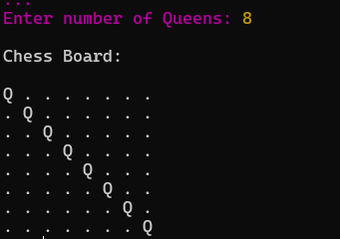

Result:
Hence, the Python program to solve the 8-Queen Problem was executed successfully.

